<Genealogy>
Design Document
Version <1.1>

INSTRUCTOR | LEVENT AKIN
STUDENT | EMİN ŞENAY
STUDENT ID | 2002103907
YEAR | 2004/2nd TERM

Revision History
Date | Version | Description | Author
<25/05/2004> | <1.0> | <Main SDD> | <Emin Şenay>
<08/06/2004> | <1.1> | <Some Fixes> | <Emin Şenay>

Table of Contents
1. Introduction 4
2. Internal Module Design 4
3.1 Class Diagram 4
3.2 Class Descriptions 4
3.2.1 Class <Operations> 4
3.2.2 Class <TreeList> 5
3.2.3 Class <Person> 6
3.2.4 Struct <family> 7

Design Document

Introduction
There are some changes in some classes, some data members changed, some members are added. In addition, there are some changes in functions. Return types of some functions are changed, and some functions are added.
SDD update contains only changed and added parts.

Internal Module Design

Class Diagram
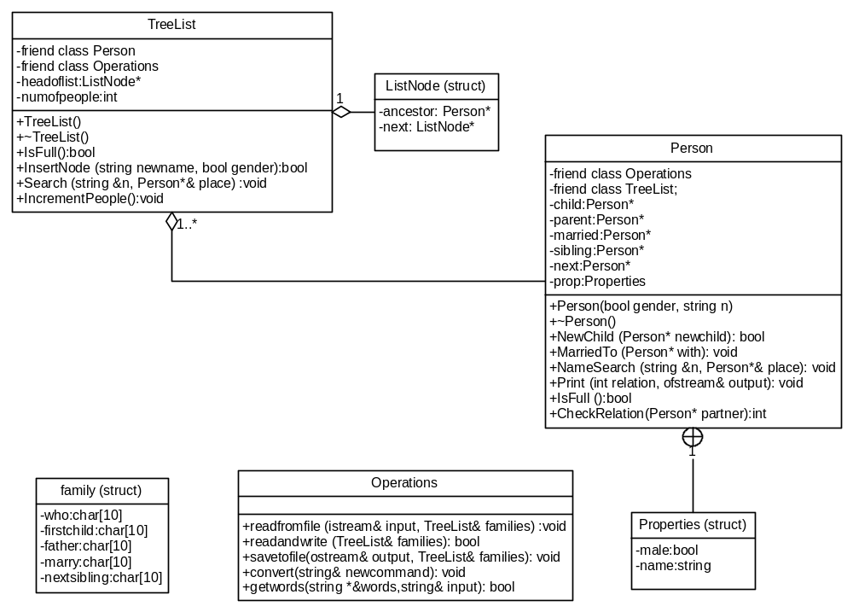

Class Descriptions

Class <Operations>
3.2.1 | Operations
 | 3.2.1.1 | Class decomposition
 |  |  | Inherited classes: -
 |  |  | Aggregated classes: -
 |  |  | Associated classes: TreeList
 |  |  | Data members: -
Member functions:
bool getwords(string *&words, string &input): Taking words from the screen
 | 3.2.1.2 | Function Decomposition
 |  |  | Function Name: getwords
 |  |  | Return Type: bool
 |  |  | Input parameter: None
 |  |  | Output parameter: string input, string *&words
 |  |  | Files accessed: None
 |  |  | Files changed: None
 |  |  | Caller: Operations::readandwrite
 |  |  | Pre: None
 |  |  | Post: Command is taken from the screen and all of the words are separated.
 |  |  | Algorithm (Description in pseudo-code): Clear the contents of the string* to prepare it to take new words. Get one line from the screen, set input to this line. If input contains nothing, warn the user and take a new line. Beginning from the words[0], set all of the words of the command to different members of the words*. If there are much than 6 words, return false. If one of the words contains more than 30 letters, return false. Else, return true.

Class<TreeList>
3.2.2 | TreeList
 | 3.2.2.1 | Class decomposition
 |  |  | Inherited classes: -
 |  |  | Aggregated classes: -
 |  |  | Associated classes: Operations, Person
Data members:
ListNode* headoflist: points the head of the list.
int numofpeople: Counts the number of people in all of the families.
Member functions:
void Search (string& n, Person &*place): Searches the given string in list and its trees.
 | 3.2.2.2 | Function Decomposition
 |  |  | Function Name: Search
 |  |  | Return Type: void
 |  |  | Input parameter: string& n
 |  |  | Output parameter: Person &*place
 |  |  | Files accessed: None
 |  |  | Files changed: None
 |  |  | Caller: Operations::readandwrite
 |  |  | Pre: Class should be constructed.
 |  |  | Post: If found, place links the person’s location. Else, place is set to NULL.
 |  |  | Algorithm (Description in pseudo-code): Set place to NULL. Beginning from the second ListNode, search the ancestor’s trees by Person::NameSearch function up to the last ListNode. If found, stop searching and return the location of person.

Class <Person>
3.2.3 | Person
 | 3.2.3.1 | Class decomposition
 |  |  | Inherited classes: None
 |  |  | Aggregated classes: TreeList
 |  |  | Associated classes: Operations
Data members:
Person* child: link to the child node.
Person* parent: Link to the father.
Person* married: Link to the partner.
Person* sibling: Link to first sibling.
Properties prop: Name and gender information.
Person* next: Next person.
Member functions:
void NameSearch (string &n, Person *&place): Searches the given name in the tree.
bool NewChild (Person* newchild): Adds a new child.
 | 3.2.3.2 | Function Decomposition
 |  |  | Function Name: NameSearch
 |  |  | Return Type: void
 |  |  | Input parameter: string &n
 |  |  | Output parameter: Person *&place
 |  |  | Files accessed: None
 |  |  | Files changed: None
 |  |  | Caller: TreeList::Search
 |  |  | Pre: Class should be constructed.
 |  |  | Post: If given name is found, place is pointing to the node of the given name. Else, place is pointing to NULL.
 |  |  | Algorithm (Description in pseudo-code): Set place to NULL. If name is the equal to the given name, set place pointer to this. Else, first search in the child nodes if child pointer is not NULL. If name cannot be found there, search in the sibling nodes if sibling pointer is not NULL.
 |  |  | Function Name: NewChild
 |  |  | Return Type: bool
 |  |  | Input parameter: Person* newchild
 |  |  | Output parameter: None
 |  |  | Files accessed: None
 |  |  | Files changed: None
 |  |  | Caller: Operations::readandwrite
 |  |  | Pre: Class should be constructed.
 |  |  | Post: New child is added to the given person.
 |  |  | Algorithm (Description in pseudo-code): If memory is full, return false. If child pointer is NULL, link child to the person’s child link. Else, traverse to the last child and link the new child to last child’s sibling link. Set next pointer of the new child. Return true.

Struct <family>
3.2.4 | family
 | 3.2.4.1 | Struct decomposition
 |  |  | Inherited classes: -
 |  |  | Aggregated classes: -
 |  |  | Associated classes: Operations
Data members:
char who[10]: Name of the person
char firstchild[10]: Name of the first child
char father[10]: Name of the father
char marry[10]: Name of the partner
char nextsibling[10]: Name of the next sibling

